ALL reference sheets and formulas on pages 10-11.

Chemistry Name

Semester 2 Chemistry Final Short Answer

Period

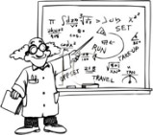
Directions: ALL work needs to be completed here in Showbie. Annotate directly and post. If you type with the text feature at all, make sure ALL of the text fits in the text box otherwise it cannot be read.

CHAPTER 9 – Chemical Reactions
- Explain why we must balance chemical reactions.
To identify the amount of each reactant required to produce a given quantity of product(s).

- Balance the following chemical equation.
Also put a S, D, SR, DR, X on the blank in front of the number to indicate the type of reaction.


KEY: S = synthesis D = decomposition SR = single replacement DR = double replacement X = combustion

X a.
2CH4O + 3O2
2CO2 + 4H2O

DR b. Pb(NO3)2 + 2KCl PbCl2 + 2KNO3

- Write a BALANCED chemical equation for each of the following reactions described. Be sure to show the states of matter.

  - Aqueous barium iodide reacts with aqueous potassium sulfate to produce aqueous potassium iodide and solid barium sulfate.

BaI_{2 (aq)} + K₂SO_{4 (aq)} BaSO_{4 (s)} + 2KI_{(aq)}

  - Hydrogen gas and oxygen gas combine to produce liquid water.

2H_{2 (g)} + O_{2 (g)} 2 H₂O _{(l)}

- Complete the following skeleton equation. These are single replacement reactions where the METAL gets replaced. THEN BALANCE it!

a. 6Li + 1Sr3(PO4)2 2Li₃PO₄ + 3Sr

b. 3Sr + 1AlF3 AlSr₃ + 3F

- Write the proper formulas of the products assuming a double replacement (cations and anions switch partners). THEN BALANCE it!

  - 2NaF + 1Mg(C2H3O)2 2NaC₂H₃O + MgF₂

  - 6FrCN + Ga2S3 3Fr₂S + 2GaCN₃

CHAPTER 2 – Sig. Figs., Sci. Not., Metric System

- Fill in the following information:

 | Number of significant  figures | Rounded to 2 significant figures | Rounded answer in scientific notation
344,750 | 6 or 5 | 340,000 | 3.4 x 10⁵
0.0080750 | 4 | 0.0081 | 8.1 x 10⁻³

- Round the final answer with proper significant figures and units.

  - 37.0 cm x 63.662 cm = 2,355.5 cm2 The answer should be 2355.5cm²

  - 90.00 g / 0.2 mL = 450 g/mL The answer should be 450g/mL

  - 22.740 m + 1.2 m = 23.94 m The answer should be 23.94m

  - 0.257 g – 0.02 g = 0.237 g The answer should be 0.237g

- Solve the problems and express the answers in scientific notation with units and the proper sig figs.

a. 4.00x102 m x 30 m 1.2 x 10⁴ m²

b. 8.00x104 g / 5.5x105 mL 1.455 x 10⁻¹ g/mL

- Complete the following conversions showing all work with the correct significant figures and units.

  - The distance between Los Angeles and San Fan Francisco taking the I-5 freeway is
614.5 km. What is this distance in meters?

1 km = 1000 m
614.5 km = (614.5 km x 1000 m)/1km
= 614500 m
= 6.145 x 10⁵ m

  - According to healthline.org, the average American male aged 20 years and above is
89.95 kg. What is this mass in milligrams?

1 kg = 1000000mg

89.95 kg = (89.95 kg x 1000000 mg)/1 kg
= 89950000 mg

= 8.995 x 10⁷ mg

- Read and record the length of the following orange line properly.
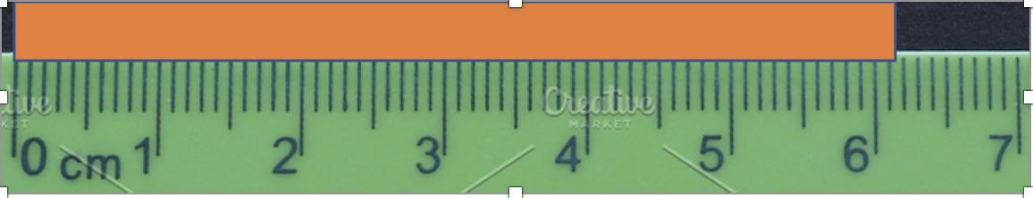

Length = 6.15 cm

- Read and record the volume on the graduated cylinder properly.
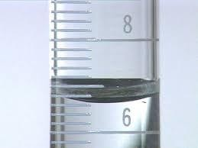

Volume = 6.60 mL

- Given the measurement, draw the instrument. It’s like #11 in reverse.
Volume = 18 ± 1 mL

- Using the data in Data Table 1-1 and images of the graduated cylinders, determine the density of the aluminum cube by answering a-d.

Table 1-1.
Mass of the Aluminum Cube | (Vi) Initial Volume of Water | (Vf) Final Volume of Water | Volume of the Aluminum cube | Density of the Aluminum Cube
19.20 ± 0.01g | 21.0mL | 27.0mL | 6.0mL | 3.2g/cm³

- 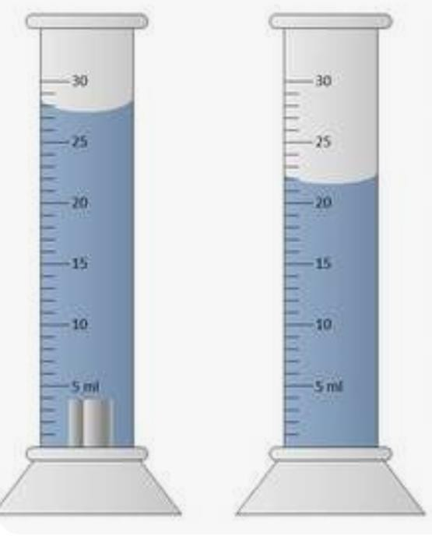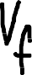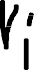Record the initial volume of water in Table 1-1 with proper ± and units.
- Record the final volume of water in Table 1-1 with proper ± and units.
- Calculate the volume of aluminum cube and record in Table 1-1.
- Calculate the density of the aluminum cube and record in Table 1-1. Show ALL work below. ACE it!

V_{i} = 21.0mL, V_{f} = 27.0mL

Volume of aluminum cube = V_{f} - V_{i}

= 27.0 – 21.0

= 6.0mL

Density = mass/ volume

= 19.2g/6.0mL

= 3.2g/cm³

CHAPTER 10 - Moles

- Complete the following conversions showing all work with the correct significant figures and units.

  - If you have 18.0 grams of Ca, how atoms of Ca is this?

40.0 g = 6.02 x 10²³ atoms

18.0 g =

(18.0 x 6.02 x 10²³ atoms)/40.0

= 2.71 x 10²³ atoms of Ca

  - How many moles of Ba(MnO4)2 are in 355 grams of Ba(MnO4)2?

Moles = mass/molar mass

= 355/ (137 + (55 +64)2)

= 355/ 375

= 0.9467 moles of Ba(MnO4)2

  - 1.40x1025 molecules of NF3 would contain what volume of NF3?

6.02 x 10²³ molecules = 1 mole

1.40 x 10²⁵ molecules = 23.26 moles

1 mole = 22.4 L

23.26 moles = 23.26 x 22.4

= 521.02 L

- a. Determine the percent composition of each element in Na2C2O4.

Na- 46 x 100%/134  = 34.33%  C- 24 x 100%/134  = 17.91% | O- 64 x 100%/134  = 47.76%

b. How many grams of sodium are in a 150 gram sample of Na2C2O4?

(46 x 150) / 134

= 51.49g

- Use the < , >, or = sign in the chart to compare the values in each row of the table for C2H2 and NH3. (Hint: Use your intuition first, then if you are stuck, try to solve each side individually and compare them)

HF | < , > , = | PF3
% Fluorine | < | % Fluorine
Molar Mass | > | Molar Mass
# Molecules in one mole | = | #Molecules in one mole
Mass of 2 moles | > | Mass of Avagadro’s # of molecules
# Molecules in 50 g | > | # Molecules in 50 g
# Moles in 3.02x1023 molecules | = | 1/2 Mole of molecules
Mass of 2 mole | > | Mass of 1 moles

CHAPTER 11 – Stoichiometry

- Ammonia is useful in many applications like detergents and fertilizers. The following reaction is how ammonia is commercially produced:

1N2 + 3H2 2NH3

- Balance the reaction above.

- Determine the reaction type. Synthesis reaction

- If 45,000 g of H2 are reacted, how many moles of N2 would have to be reacted with it?

Moles of Hydrogen = 45000/2

= 22500 moles

Moles of Nitrogen = moles of Hydrogen/3 = 22500/3 moles = 7500 moles
- If 45,000 g of H2, what mass (in grams) of NH3 can theoretically be formed?
Moles of ammonia = 7500 x 2 = 15000 moles
Mass of ammonia = moles x molar mass
= 15000 x 17
= 255000g

- Using the information from part (d), what is the percent yield of NH3 if 240,000 grams of NH3 are actually produced during the reaction? ACE it!

% yield = (240000 x 100%)/255000

= 94.12%

CHAPTER 13 – Gas Laws
- Hot-Air Balloons. A sample of air occupies 2.50 L at a temperature of 22.0°C. What volume will this sample occupy inside a hot-air balloon at a temperature of 43.0°C? Assume that the pressure inside the balloon remains constant. ACE it! (Hint: temperature scale…nuff said)

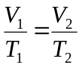= 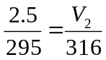

V₂ = 2.68 L

- A certain chemistry teacher carefully placed 3.40 gram chunk of dry ice (solid CO2) into an empty half liter (.500L) water bottle that he found in the recycling bin. The dry ice converted entirely into a gaseous CO2.

- How many moles of CO2 filled the bottle from the 3.40 gram chunk CO2?

Moles = mass/ molar mass

= 3.4/44

= 0.0772 moles

- Plastic bottles will burst if there is too much pressure in the container resulting in a very explosive and dangerous situation. Assuming all of the CO2 reached room temperature at 25°C, determine the pressure (atm) of the CO2 filling the bottle. ACE it!

What temperature scale must be used? Kelvin

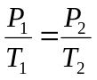= 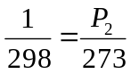

P₂ = 0.916 atm.

- Knowing that most plastic water bottles can only withstand about 3 atm of pressure, was it actually safe for the teacher to put in that much dry ice into the container or was it a bonehead move? Use your answer from “b” to justify your answer.
It was safe for the teacher to add more dry ice so as to increase pressure as the pressure obtained is low.

- Why does pressure get created as the solid CO2 converts to gas. You must use the words
particles, collisions, and frequency in your explanation.

As the solid CO₂ is converted to gas, the kinetic energy of the particle incease, which increases the frequency of the vibration and collision of the particles hence they move further apart. Increased collision of the particles leads to increase in pressure.

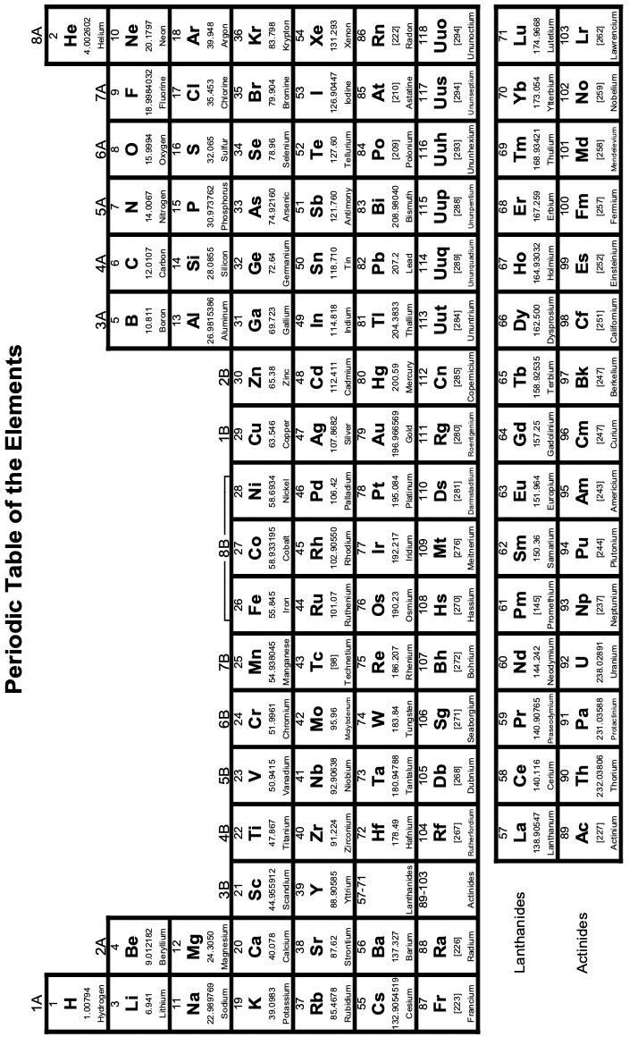


Writing Compound FORMULAS

Type 1 – Ionic M/Non M/Poly M/Trans

Type 2 – Covalent/Molecular
N/N - use #prefixes to write formula

Type 3 - Diatomics
Br2 I2 N2 Cl2 H2 O2 F2

Type 4 – Just an element!
Ex: Fe, Ar, C, B, Ag
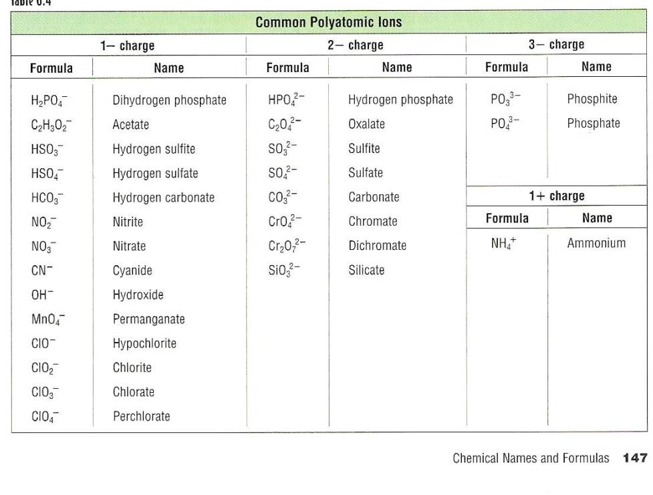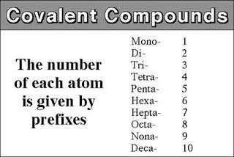
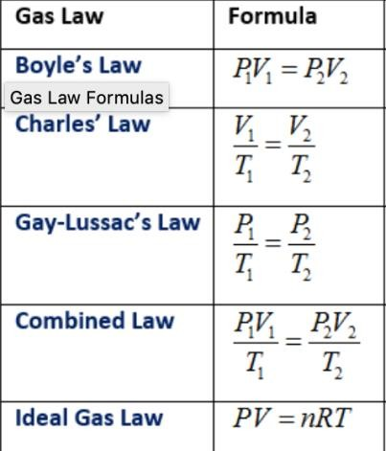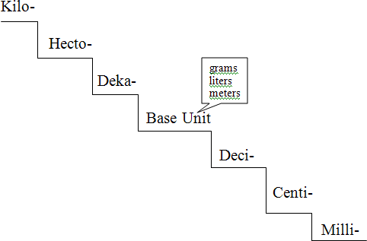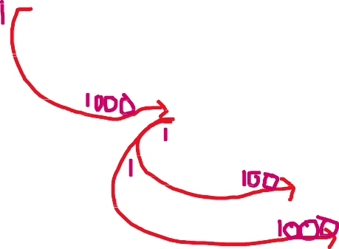
6.02x1023
Particles
(atoms, molecules)
Mole /
Mole
1
Mole
22.4L
(@STP)
Molar
Mass Grams
(PT)
(𝐾𝑒𝑙𝑣𝑖 = 𝐶𝑒𝑙𝑠𝑖𝑢𝑠 + 273
(𝐺𝑎𝑠 𝑐𝑜𝑛𝑠𝑡𝑎𝑛 = 0.0821 𝐿 𝑎𝑡𝑚/𝑚𝑜𝑙 𝐾)

